
LjunggrenAudio RYO 3xVCA
a Triple linear VCA in 4hp

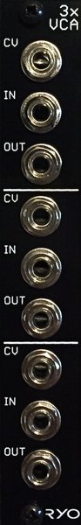

- triple hi-fidelity OTA-based modern VCA.
- All analogue circuitry.
- hi-fidelity signal chain with low noise opamps and OTAs.
- Buffered inputs and outputs.
- slim 4HP footprint.
- compact 51mm Depth (with power cable attached).
- low power draw: 26mA +12V / 21mA -12V / no +5V required.
- Works for audio as well as CV.
- Fast responding CV inputs allow for complex modulation and modulating with audio signals.
- ch1 output normalized to ch2 input cascading for expo response and patching convenience.
- ch2 output normalized to ch3 input cascading for expo response and patching convenience.
- can be callibrated to give above 1.0x gain at +8V CV

downloads
* user manual
* quickstart guide
* assembly guide
* hi-res schematic
* datasheet
* BOM

